CASCO AREA WORKSHOP, INC.
_________________________________________
AGENCY NAME

Title VI Program

Date filed with MoDOT Transit Section:

___November 29, 2017______________
DATE

This TEMPLATE is provided by the Missouri Department of Transportation (MoDOT) Transit Section, as a resource for producing the triennial Title VI Program document for Federal Transit Administration recipients and subrecipients. FTA Circular 4702.1B, dated October 1, 2012, “Title VI Requirement and Guidelines for Federal Transit Administration Recipients” was the primary source of material for this template. Use of this template does not override each agency’s responsibility to interpret the requirements as expressed in FTA Circular 4702.1B, or as amended in the future.

This template is available online, through a link at: http://www.modot.org/othertransportation/transit/transitapplicationsreportsprograms.htm
Check this link periodically for most recent, dated template updates.
12/10/13

Title VI Plan
Table of Contents

- Introduction / Title VI Assurances page 2
- Agency Information page 3
- Notice to the Public page 4
- Procedure for Filing a Title VI Complaint page 5
- Title VI Complaints, Investigations, Lawsuits page 7
and Evidence of Agency Staff Title VI Training
- Public Participation Plan page 8
- Language Assistance Plan page 11
- Advisory Bodies page 15
- Subrecipient Assistance page 16
- Subrecipient Monitoring page 17
- Equity Analysis of Facilities page 18
For Fixed Route Transit Providers
- Standards and Policies page 19
- Data Reporting and Collection page 20
- Transit Service Monitoring page 21
- Service and Fare Equity Changes page 22

Attachments
Attachment 1 – Agency Information (Sample)
Attachment 2 – Title VI Complaint Form
Attachment 3 – Title VI Self Survey Form

10/30/13
A. Title VI Assurances
Casco Area Workshop, Inc. agrees to comply with all provisions prohibiting discrimination on the basis of race, color, or national origin of Title VI of the Civil Rights Act of 1964, as amended, 42 U.S.C. 200d et seq., and with U.S. DOT regulations, “Nondiscrimination in Federally-Assisted Programs of the Department of Transportation – Effectuation of Title VI of the Civil Rights Act,” 49 CFR part 21.

Casco Area Workshop, Inc. assures that no person shall, as provided by Federal and State civil rights laws, be excluded from participation in, be denied the benefits of, or be subjected to discrimination under any program or activity. Casco Area Workshop, Inc. further ensures every effort will be made to ensure non-discrimination in all programs and activities, whether those programs and activities are federally funded or not.

Casco Area Workshop, Inc. meets the objectives of the FTA Master Agreement which governs all entities applying for FTA funding, including Casco Area Workshop, Inc. and its third-party contractors by promoting actions that:

- Ensure that the level and quality of transportation service is provided without regard to race, color, or national origin.

- Identify and address, as appropriate, disproportionally high and adverse effects of programs and activities on minority populations and low-income populations.

- Promote the full and fair participation of all affected Title VI populations in transportation decision making.

- Prevent the denial, reduction, or delay in benefits related to programs and activities that benefit minority populations or low-income populations.

- Ensure meaningful access to programs and activities by persons with Limited English Proficiency (LEP).

B. Agency Information
See sample B. Agency Information
ATTACHMENT 1

- Mission of Casco Area Workshop, Inc.
The mission guides the operations of the organization.
Casco exists to provide meaningful experience to people with disabilities which enable them to increase their independence. Our goal is to enhance the quality of life for the people we serve through growth, experience and community inclusion.
Our goal is accomplished by:
- Providing the opportunity for meaningful experience both within our facility and within the community.
- Respecting the rights, choices and dignity of all people.
- Encouraging each person to expand their talents to reach their desired level of independence, integration and inclusion.
- Advocating for the inclusion of people with disabilities in all aspects of community life.
Through these actions we defend each person's right to be independent and productive and to contribute toward their own welfare and that of their community.
OUR MOTTO
PRIDE AND INDEPENDENCE THROUGH EXPERIENCE AND INCLUSION

- History (including year started)
- CASCO AREA WORKSHOP, INC.
- ORGANIZATIONAL HISTORY

- 1958 First Sheltered Workshop in Missouri
- April 17, 1972 Cass County Sheltered Workshop Association organized as a
- non-profit corporation to transport 11 workers to Grandview
- October 27, 1973 Workshop moved to 2001 N. Commercial in Harrisonville
- Ed Heitman, President
- November 14, 1975 Discontinued as satellite of Greater Kansas City Foundation
- Workshop
- December 1, 1975 Certified as the 55th Sheltered Workshop in Missouri
- December 20, 1975 KIEE-FM sponsored a telethon to benefit the Workshop
- raising over $6,000
- April 6, 1976 Tax levy of $.05 per $100 assessed valuation was passed by a 3 to 1
- Countywide vote
- July 1976 Cass County Sheltered Workshop Association elected Board of
- Directors to operate the Sheltered Workshop: Asa Skelton, President;
- Paul Shadduck, Vice President; Goldie Diamond, Secretary;
- Sharon Love, Treasurer; Marian Griffin, Marilyn Moreland,
- Richard Barr, Robert Murphy and Frank Mickelson, Board Members
- December 1976 County Court judges J. Weldon Jackson, Frank Clary, and
- Robert Jones appointed the first County Board to receive county tax levy:
- Ed Heitman, Romulus Pitts, Belton;
- Don Harper, Peculiar; Dorothy Vaughn, Pleasant Hill;
- Joann Johnson, Arlo Murdock, Richard Hubble, Harrisonville;
- Clyde Thomas, Drexel; Gerald Walker, Creighton
- January 1977 Gerald Lawler hired as Manager. Mr. Lawler managed until 1985
- February 1977 Organization name changed to Casco Area Workshop, Inc.
- July 1977 Board elected Irene Webster President
- November 10, 1977 IRS exemption approved
- January 12, 1978 Building plans by John Foster accepted
- February 12, 1978 Ground breaking held at 1800 Vine
- November 19, 1978 Dedication and Open House held
- November 1985 Peggy Kutchback hired as Executive Director
- September 21, 1987 Groundbreaking held for building addition
- June 25, 1988 Dedication and Open House for the new addition
- November 1991 Supported Employment Program began
- June 1993 .PEP (Production Enhancement Project) began
- March 1994 Added 5,000 sq. ft. warehouse funded by County Board
- April 1995 Day Habilitation Program began
- July 1997 Assumed management of Tri County Workshop. Name changed to
- Bates County Industries
- August 1997 Added 5,000 sq. ft. warehouse funded by Cass County Board of Services
- April 1998 Established Bates County Board of Services to fund
- Bates County Industries
- November 1998 Added 3,000 sq. ft. warehouse to Harrisonville location funded by
- Cass County Board of Services
- July 2000 NISH sewing projects began
- July 17, 2000 Groundbreaking for Bates County Industries new building
- June 5, 2001 Open House for new Bates County Industries building
- November 12, 2001 Irene Webster-Pippitt, Board President, died.
- November 26, 2001 Wayne Reid assumed Presidency
- December 1, 2002 BCI Board assumed operation of Bates County facility
- March 26, 2003 Wayne Reid retired from the Board
- March 2003 John Fogel appointed to Board of Directors
- April 28, 2003 John Kohler assumed Presidency
- May 15, 2003 BCI certified as a separate workshop
- June 2003 Charlotte Huhn Appointed as Board Member
- May 2004 Marian Griffin passed away
- June 2004 John Kohler passed away
- June 2004 Karen Meador appointed as President
- June 2004 Bill Griffin appointed to Board of Directors
- June 2004 Sharon Cumpton appointed to Board of Directors
- November 2004 Marilyn Petersen passed away
- December 2005 1802 Vine was purchased
- August 2006 Jill Smith resigned as Board Member
- September 2006 Dan Powell appointed as Board Member
- February 2007 Bill Griffin passed away
- March 2007 Beverly Bahm resigned as Board Member
- May 2007 Mike Wagner appointed to Board
- May 2007 Jill Smith rejoined the Board of Directors
- July 2007 Targeted Case Management began
- February 2009 Sharon Marshall appointed to Board of Directors
- March 2009 Tom Clatworthy resigned from Board of Directors
- August 2009 Began clothing recycling project
- May 2010 Expanded recycling to include cardboard
- August 2010 Leased Tall Grass facility
- November 2010 Opened Tall Grass Treasures
- July 2011 Opened Contact Center
- Sept 2011 Wayne Scrudder appointed to the Board of Directors
- November 2011 Diane Bolinger appointed to Board of Directors
- April 2012 Closed Contact Center
- April 2012 Moved recycling to Wayne Reid Annex
- July 2012 Moved Tall Grass Treasures to Gaslight Shopping Center
- Admin offices relocated to Annex. TCM moved to 1800 Vine
- February 2013 Terry Wilson appointed to Board of Directors
- March 2013 Nancy Baalman appointed to Board of Directors
- October 2013 Terry Wilson resigned from Board of Directors
- November 2013 Charlotte Huhn moved to Honoree Member of Board of Directors
- February 2014 Jill Smith resigned from Board of Directors
- May 2014 Katie Huff appointed to Board of Directors
- November 2014 Robert Greenwood Hired as Executive Director
- March 2015 Jerry Johnson appointed to the Board of Directors
- April 2015 Closed Tall Grass Treasures
- June 2016………………………………………………………Peggy Kutchback appointed to Board of Directors
- September 2017………………………………………………Goldie Diamond retired from Board of Directors
- October 2017……………………………………………………Crystal Osborn appointed to Board of Directors

- Regional Profile (regional population; growth projection)
Casco provides to and from transportation for individuals with disabilities who attend Casco’s programs (ie: Workshop & Day Program), transportation to and from community employment for individuals placed through our Community Employment Program, and for those participating in the Day Program (Community Based program) experiencing and participating in activiiteis out in the community.
Casco Area Workshop, Inc. main serves area is Cass County Missouri area total population of 99,478 (per Cenus), we have 200 plus we provide transporation to on a daily basis. We also transport into the surrounding counties (Bates, Jackson, Johnson, & Henry) for various reasons (employment, recreational, educational, etc.)

- Population served (in relation to regional population)
Casco Area Workshop, Inc. serves people with disabilities. We have multiple programs and currently those who utilalize our transportation are adults with disabilities. We also occasionaly serve elderly by transporting them to special functions in the city.

- Service area (include map, with any routes utilized)
Cass, Jackson, Bates, Henry, Johnson County
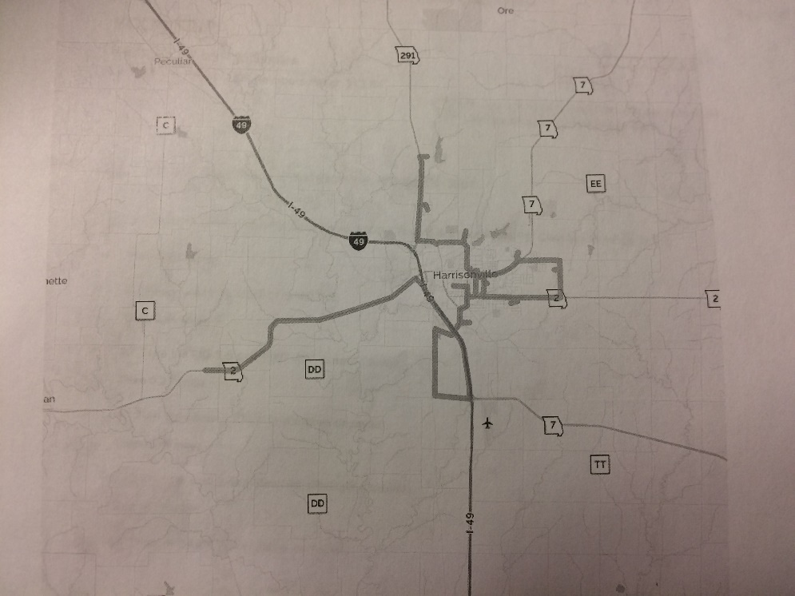
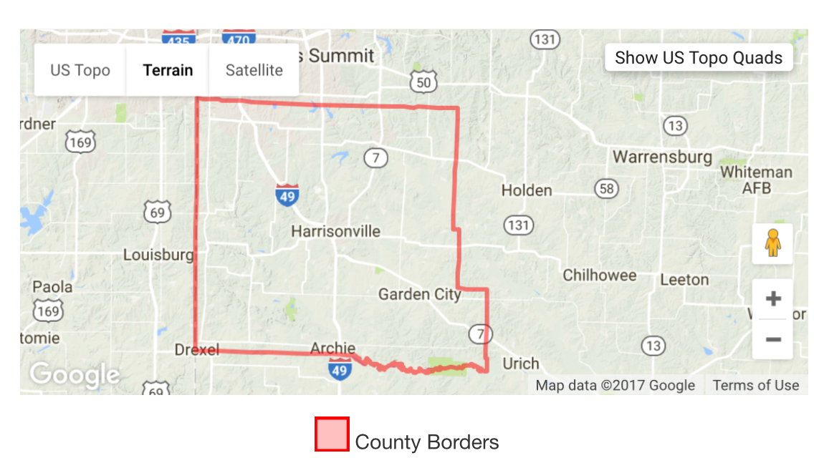

- Governing body make-up (include terms of office)

Robert Greenwood Hired: 11/2014
Excutive Director

Karen Meador Term: 2020
President

Dave Petersen Term: 2020
Vice President

Sharon Marshall Term: 2018
Secretary

Sharon Cumpton Term: 2020
Treasurer

Nancy Baalman Term 2019
Board Member

John Fogle Term 2020
Board Member

Katie Huff Term 2020
Board Member

Jerry Johnson Term 2018
Board Member

Peggy Kutchback Term 2019
Board Member

Crystal Osborn Term 2020
Board Member

Wayne Scrudder Term 2018
Board Member

Mike Wagner Term 2020
Board Member
10/30/13
C. Notice to the Public

Notifying the Public of Rights under Title VI

Casco Area Workshop, Inc. posts Title VI notices on our agency’s website, in public areas of our agency, in our board room, and on our buses and/or paratransit vehicles.

Casco Area Workshop, Inc. operates its programs and services without regard to race, color, or national origin, in accordance with Title VI of the Civil Rights Act of 1964.

For more information on the Casco Area Workshop, Inc.’s Title VI program, and the procedures to file a complaint, contact Rachel Schliem at 816-380-7359; rachel@casco-aw.org; or visit our administrative office at 1800 Vine, Harrisonville, Mo 64701. For more information visit www.casco-aw.com .

If you believe you have been discriminated against on the basis of race, color, or national origin by Casco Area Workshop, Inc., you may file a Title VI complaint by completing, signing, and submitting the agency’s Title VI Complaint Form.

How to file a Title VI complaint with Casco Area Workshop, Inc.:

- How to obtain Complaint Form: Contact the Program Support Manager at 1800 W. Vine, Harrisonville, Mo 64701.

- In addition to the complaint process at Casco Area Workshop, Inc., complaints may be filed directly with the Federal Transit Administration, Office of Civil Rights, 901 Locust Street, Room 404, Kansas City, Mo 64106, Phone: 816-329-3920.

- Complaints must be filed within 180 days following the date of the alleged discriminatory occurrence and should contain as much detailed information about the alleged discrimination as possible.

- The form must be signed and dated, and include your contact information.

If information is needed in another language, contact Program Support Manager [816-380-7359].

D. Procedure for Filing a Title VI Complaint
See sample Title VI Complaint Form
ATTACHMENT 2

Filing a Title VI Complaint

The complaint procedures apply to the beneficiaries of Casco Area Workshop, Inc’s programs, activities, and services.

RIGHT TO FILE A COMPLAINT: Any person who believes they have been discriminated against on the basis of race, color, or national origin by Casco Area Workshop, Inc may file a Title VI com-plaint by completing and submitting the agency’s Title VI Complaint Form. Title VI complaints must be received in writing within 180 days of the alleged discriminatory complaint.

HOW TO FILE A COMPLAINT: Information on how to file a Title VI complaint is posted on our agency’s website, and in public areas of our agency.

You may download the Casco Area Workshop, Inc Title VI Complaint Form at www.casco-aw.com, or request a copy by writing to 1800 Vine, Harrisonville, Mo 64701. Information on how to file a Title VI complaint may also be obtained by calling Program Support Manger at [816-380-7359].

You may file a signed, dated complaint no more than 180 days from the date of the alleged incident. The complaint should include:

- Your name, address and telephone number.
- Specific, detailed information (how, why and when) about the alleged act of discrimination.
- Any other relevant information, including the names of any persons, if known, the agency should contact for clarity of the allegations.

Please submit your complaint form to Casco Area Workshop, Inc., 1800 Vine, Harrisonville, MO 64701.

COMPLAINT ACCEPTANCE: Casco Area Workshop, Inc will process complaints that are complete. Once a completed Title VI Complaint Form is received, Casco Area Workshop, Inc will review it to determine if Casco Area Workshop, Inc has jurisdiction. The complainant will receive an acknowledgement letter informing them whether or not the complaint will be investigated by Program Support Manager.

INVESTIGATIONS: Casco Area Workshop, Inc will generally complete an investigation within 90 days from receipt of a completed complaint form. If more information is needed to resolve the case, Casco Area Workshop, Inc may contact the complainant. Unless a longer period is specified by Casco Area Workshop, Inc, the complainant will have ten (10) days from the date of the letter to send requested information to the Casco Area Workshop, Inc investigator assigned to the case.

If the requested information is not received within that timeframe the case will be closed. Also, a case can be administratively closed if the complainant no longer wishes to pursue the case.

LETTERS OF CLOSURE OR FINDING: After the Title VI investigator reviews the complaint, the Title VI investigator will issue one of two letters to the complainant: a closure letter or letter of finding (LOF).

- A closure letter summarizes the allegations and states that there was not a Title VI violation and that the case will be closed.

- A Letter of Finding (LOF) summarizes the allegations and provides an explanation of the corrective action taken.

If the complainant disagrees with Casco Area Workshop, Inc’s determination, the complainant may request reconsideration by submitting the request in writing to the Title VI investigator within seven (7) days after the date of the letter of closure or letter of finding, stating with specificity the basis for the reconsideration. Casco Area Workshop, Inc will notify the complainant of the decision either to accept or reject the request for reconsideration within ten (10) days. In cases where reconsideration is granted, Casco Area Workshop, Inc will issue a determination letter to the complainant upon completion of the reconsideration review.

A person may also file a complaint directly with the Federal Transit Administration, at the FTA Office of Civil Rights, 1200 New Jersey Avenue SE, Washington, DC 20590.

If information is needed in another language, contact Program Support Manager at Casco Area Workshop, Inc., 1800 Vine, Harrisonville, MO 64701., or at 816-380-7359.

E. Monitoring Title VI Complaints, Investigations, Lawsuits
See sample Title VI Self-Survey Form
ATTACHMENT 3
and Documenting Evidence of Agency Staff Title VI Training

Documenting Title VI Complaints/Investigations

All Title VI complaints will be entered and tracked in Casco Area Workshop, Inc.’s complaint log. Active investigations will be monitored for timely response on the part of all parties. The agency’s Title VI Coordinator shall maintain the log.

Agency Title VI Complaint Log

Date complaint filed | Complainant | Basis of complaint R-C-NO | Summary of allegation | Pending status of complaint | Actions taken | Closure Letter (CL) | Letter of Finding (LOF) | Date of CL or LOF

Documenting Evidence of Agency Staff Title VI Training

Casco Area Workshop, Inc’s staff are given Title VI training, and agency can answer affirmatively to all the following questions:

- Are new employees made aware of Title VI responsibilities pertaining to their specific duties?
- Do new employees receive this information via employee orientation?
- Is Title VI information provided to all employees and program applicants?
- Is Title VI information prominently displayed in the agency and on any program materials distributed, as necessary?

10/30/13
F. Public Engagement Plan

Goal

The goal of the Public Engagement Plan is to have significant and ongoing public involvement, by all identified audiences, in the public participation process for major agency outreach efforts.

Objectives

- To understand the service area demographics and determine what non-English languages and other cultural barriers exist to public participation.

- To provide general notification of meetings and forums for public input, in a manner that is understandable to all populations in the area.

- To hold public meetings in locations that are accessible to all area stakeholders, including but not limited to minority and low income members of the community.

- To provide methods for two-way communication and information and input from populations which are less likely to attend meetings.

- To convey the information in various formats to reach all key stakeholder groups.

Identification of Stakeholders

Stakeholders are those who are either directly or indirectly affected by an outreach effort, system or service plan or recommendations of that plan. Stakeholders include but are not limited to the following:

- Board of Directors – the governing board of the agency. The role of the Board is to establish policy and legislative direction for the agency. The Board defines the agency’s mission, establishes goals, and approves then budget to accomplish the goals.
- Advisory Bodies – non-elected advisory bodies review current and proposed activities of the agency, and are encouraged to be active in the agency’s public engagement process. Advisory bodies provide insight and feedback to the agency.
- Agency Transit riders and clients
- Minority and low income populations, including limited English proficient persons
- Local jurisdictions and other government stakeholders
- Private businesses and organizations
- Employers
- Partner agencies

Elements of the Public Engagement Plan

It is necessary to establish a public participation plan that includes an outreach plan to engage minority and limited English proficient (LEP) populations.

Elements of the Public Engagement Plan include:

- Public Notice
  - Official notification of intent to provide opportunity for members of the general public to participate in public engagement plan development, including participation in open Board/council meetings, and advisory committees.

- Public Engagement Process/Outreach Efforts:
  - Public meetings
  - Open houses
  - Rider forums
  - Rider outreach
  - Public hearings
  - Focus groups
  - Surveys
  - Services for the Disabled (Notices of opportunities for public involvement include contact information for people needing these or other special accommodations.)

Events such as public meetings and/or open houses are held at schools, churches, libraries and other non-profit locations easily accessible to public transit and compliant with the Americans with Disabilities Act.

- Public Comment
  - Formal public comment periods are used to solicit comments on major public involvement efforts around an agency service or system change.
  - Comments are accepted through various means:
    - Dedicated email address.
    - Website.
    - Regular mail.
    - Forms using survey tool for compilation.
    - Videotaping.
    - Phone calls to Customer Service Center [phone]

- Response to Public Input

All public comments are provided to the Board of Directors prior to decision making. A publicly available summary report is compiled, including all individual comments.

Title VI Outreach Best Practices

Casco Area Workshop, Inc ensures all outreach strategies, communications and public involvement efforts comply with Title VI. Casco Area Workshop, Inc’s Public Engagement Plan proactively initiates the public involvement process and makes concerted efforts to involve members of all social, economic, and ethnic groups in the public involvement process. Aligned with the above referenced communication tactics, Casco Area Workshop, Inc provides the following:

- Public notices published in non-English publications (if available).
- Title VI non-discrimination notice on agency’s website.
- Agency communication materials in languages other than English (subject to Safe Harbor parameters).
- Services for Limited English Proficient persons. Upon advance notice, translators may be provided.

2013 – 2016 Title VI Program Public Engagement Process

Casco Area Workshop, Inc will conduct a Public Engagement Process for the 2013-2016 Title VI Program. This process includes survey and highlight key components of the Title VI Plan. Materials have been created to explain Title VI policies as well as provide education on how they relate to minority populations.

Casco Area Workshop, Inc will provide briefings to the Board of Directors and Advisory Bodies.

Casco Area Workshop, Inc will conduct a 30 day public comment period to provide opportunities for feedback on the 2013-2016 Title VI Program.

Comments are accepted during the public outreach period via:
- Email
- Mail
- Phone
- In person
- Survey tool (agency option)

Summary of 2010-2012 Public Outreach Efforts

G. Language Assistance Plan

Casco Area Workshop, Inc Limited English Proficiency Plan

This limited English Proficiency (LEP) Plan has been prepared to address Casco Area Workshop, Inc ‘s responsibilities as a recipient of federal financial assistance as they relate to the needs of individuals with limited language skills. The plan has been prepared in accordance with Title VI of the Civil Rights Act of 1964; Federal Transit Administration Circular 4702.1B, dated October 1, 2012, which states that the level and quality of transportation service is provided without regard to race, color, or national origin.

Executive order 13166, titled “Improving Access to Services for Persons with Limited English
Proficiency,” indicates that differing treatment based upon a person's inability to speak, read, write or understand English is a type of national origin discrimination. It directs each federal agency to publish guidance for its respective recipients clarifying their obligation to ensure that such discriminations do not take place. This order applies to all state and local agencies which receive federal funds.

Service Area Description:
Service in Cass County Missouri and surrounding counties (Bates, Jackson, Johnson & Henry).

Casco Area Workshop, Inc has developed this LEP Plan to help identify reasonable steps for providing language assistance to persons with limited English proficiency who wish to access services provided by Casco Area Workshop, Inc. As defined in Executive Order 13166, LEP persons are those who do not speak English as their primary language and have limited ability to read, speak, write or understand English. This plan outlines how to identify a person who may need language assistance, and the ways in which assistance may be provided.

In order to prepare this plan, Casco Area Workshop, Inc. undertook the four-factor LEP analysis which considers the following factors:

Four Factor Analysis

1. The number and proportion of LEP persons eligible to be served or likely to be encountered in the service area:

A significant majority of people in the Casco Area Workshop, Inc service area are proficient in the English language. Based on 2010 Census data, [12%] of the population five years of age and older speak English “less than very well” – a definition of limited English proficiency

LEP Population in Casco Area Workshop, Inc Service Area
Population 5 years and over by language spoken at home and ability to speak English | Service Area Sector [1] | Service Area Sector [1] | Service Area Sector [1] | Service Area Total | Percentage of Population 5 Years and Older
Population 5 Years and Over
Speak English “less than very well”
Spanish
Speak English “less than very well”
Other Indo-European
Speak English “less than very well”
Asian and Pacific Island
Speak English “less than very well”
All Other
Speak English “less than very well”

2. Frequency of Contact by LEP Persons with Casco Area Workshop, Inc’s Services:

The Casco Area Workshop, Inc staff reviewed the frequency with which office staff, dispatchers and drivers have, or could have, contact with LEP persons. To date, Casco Area Workshop, Inc has, on average, only one requests per month for an interpreter. Casco Area Workshop, Inc averages zero phone calls per month.

LEP Staff Survey Form

Casco Area Workshop, Inc is studying the language assistance needs of its riders so that we can better communicate with them if needed.

- How often do you come into contact with passengers who do not speak English or have trouble understanding you when you speak English to them?
DAILY WEEKLY MONTHLY LESS THAN MONTHLY

- What languages do these passengers speak?
- What languages (other than English) do you understand or speak?
- Would you be willing to serve as a translator when needed?

Frequency of Contact with LEP Persons
Frequency | Language Spoken by LEP Persons
Daily
Weekly
Monthly
Less frequently than monthly

3. The importance of programs, activities or services provided by Casco Area Workshop, Inc to LEP persons:

Outreach activities, summarized in Casco Area Workshop, Inc’s Title VI Public Engagement Plan, include events such as public meetings and/or open houses held at schools, churches, libraries and other non-profit locations, and include specific outreach to LEP persons to gain under-standing of the needs of the LEP population, and the manner (if at all) needs are addressed.

Outside Organization LEP Survey

Organization: Casco Area Workshop, Inc
- What language assistance needs are encountered?
- What languages are spoken by persons with language assistance needs?
- What language assistance efforts are you undertaking to assist persons with language assistance needs?
- When necessary, can we use these services?

4. The resources available to Casco Area Workshop, Inc _ and overall cost to provide LEP assistance:

Strategies for Engaging Individuals with Limited English Proficiency include:
- Language line. Upon advance notice, translators can be provided.
- Language identification flashcards.
- Written translations of vital documents (identified via safe harbor provision)
- One-on-one assistance through outreach efforts.
- Website information.
- To the extent feasible, assign bilingual staff for community events, public hearings and Board of Directors meetings and on the customer service phone lines.

As applicable: Based on our demographic analysis (Factor 1) Casco Area Workshop, Inc has determined that no language group(s) within its service area meets Safe Harbor criteria requiring written translated “vital documents” by language group(s).

Casco Area Workshop, Inc will provide assistance and direction to LEP persons who request assistance.
10/30/13

Staff LEP Training

The following training will be provided to Casco Area Workshop, Inc staff:
1. Information on Casco Area Workshop, Inc Title VI Procedures and LEP responsibilities.
2. Description of language assistance services offered to the public.
3. Use of Language Identification Flashcards.
4. Documentation of language assistance requests.

Monitoring and Updating the LEP Plan

The LEP Plan is a component of Casco Area Workshop, Inc’s Title VI Plan requirement.

Casco Area Workshop, Inc will update the LEP plan as required. At minimum, the plan will be reviewed and updated when it is clear that higher concentrations of LEP individuals are present in the Casco Area Workshop, Inc service area. Updates include the following:

1. How the needs of LEP persons have been addressed.
2. Determine the current LEP population in the service area.
3. Determine as to whether the need for, and/or extent of, translation services has changed.
4. Determine whether local language assistance programs have been effective and sufficient to meet the needs.
5. Determine whether Casco Area Workshop, Inc 's financial resources are sufficient to fund language assistance resources as needed.
6. Determine whether Casco Area Workshop, Inc has fully complied with the goals of this LEP Plan.
7. Determine whether complaints have been received concerning Casco Area Workshop, Inc’s failure to meet the needs of LEP individual.

10/30/13
H. Advisory Bodies

Table Depicting Membership of Committees, Councils, By Race
Committee [examples] | Caucasian | Latino | African American | Asian American |  | Total
Population Committee | 12 |  |  |  |  | 100%
Access Committee |  |  |  |  |  | 100%
Citizens Advisory Council | 10 |  | 1 | 1 |  | 100%

Description of efforts made to encourage minority participation on committees:

- Quarterly Town meetings are held for everyone to voice opions or ask questions
- Monthly board meetings are held opened to the public
- Annual business business is held open to the public
- Open door policy in the company to assist or answer questions for anyone regarding transportation. Etc.

11/08/13
I. Subrecipient Assistance

Subrecipient Assistance

OPTION A

Casco Area Workshop, Inc does not have any subrecipients.

OPTION B

Primary recipients should provide subrecipients:

- Sample public notices, Title VI complaint procedures, and the recipient’s Title VI complaint form.
- Sample procedures for tracking and investigating Title VI complaints filed with a subrecipient.
- Direction regarding obtaining demographic information of population served by subrecipients.
- Technical assistance.
- Reviews of Title VI Programs; follow-up as necessary.

J. Subrecipient Monitoring

Subrecipient Monitoring

OPTION A

Casco Area Workshop, Inc does not have any subrecipients.

OPTION B

Primary recipients must monitor subrecipients.
- Non-compliant subrecipient means primary recipient is also non-compliant.

Primary recipients shall:
- Document process for ensuring all subrecipients are complying with the general and specific requirements.
- Collect and review subrecipients’ Title VI Programs.
- At FTA’s request, the primary recipient shall request that subrecipients who provide transportation services verify that their level and quality of service is equitably provided.

K. Equity Analysis of Facilities
OPTION A

Casco Area Workshop, Inc has not constructed any storage facilities, maintenance facilities, or operations centers in the last three years.

Demographic data and mapping
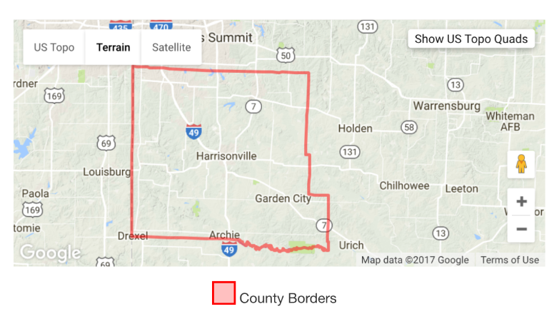

L. System-Wide Service Standards and Policies*

*applies to all fixed route providers (including those that do not meet volume threshold)

Policies (1. 2.)
is presented in detail
in FTA Circular 4702.1b Appendix H.

M. Requirement to Collect and Report Demographic Data*

*applies to providers that operate 50 or more fixed route transit vehicles in peak service; and 200,000+ population.

Template for Demographic Profile and Travel Patterns
is presented in detail
in FTA Circular 4702.1B Appendix I.

N. Requirement to Monitor Transit Service*

*applies to providers that operate 50 or more fixed route transit vehicles in peak service; and 200,000+ population.

Template for Demographic Profile and Travel Patterns
is presented in detail
in FTA Circular 4702.1B Appendix J.
O. Service and Fare Equity Analysis*

*Does not apply Casco services an area of less than 200,000.

Attachment 1

Agency Information

Casco Area Workshop, Inc. offers serveral opportunities for individiuals with disabilities. Casco has Shelter workshop which provides employment for individuals with disabilities for those individuals who choose to work and needs supports. Second program is Day Services, individuals work on daily living skills while having the opportunitiy to explore their community (ie: educationally, recreational, social, etc.), in addition the Day Service also offers Community integration where individuals are able to go out into the community and participate in various activies (volunteer, socially, educational, etc.). Casco also has Community Employment Services which assist individuals with disabilities to obtain employment out in the community. And Target Case Management for the county.
Within these program Casco provides two routes to and from Casco Transportation for those who live in the Harrisonville city limits to either participate in the Day Service or work in the Workshop. Casco also provides transportation for the individuals who have Community Integration to get out in the community. We also offer transportation for the first 90 days for individuals who obtain employment out in the community through our Community Employment Program.

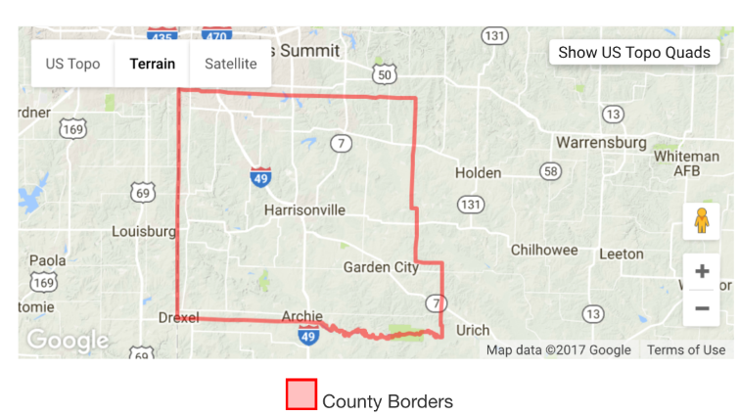

Attachment 2
Casco Area Workshop is committed to ensuring that no person is excluded from participation in or denied the benefits of our services on the basis of race, color, or national origin, as provided by the Title VI / ADA of the Civil Rights Act of 1964, as amended. Title VI / ADA complaints must be filed within 180 days from the date of the alleged discrimination.
The following information is necessary to assist us in processing your complaint. If you require any assistance in completing this form, please contact the Title VI / ADA Program Officer by calling 816-380-7359.
The completed form must be returned to Title VI / ADA Program Officer, c/o Casco Area Workshop, 1800 Vine, Harrisonville, Mo 64701.
Name:
Street Address:
City, State & Zip Code
Phone: | Alt. Phone:
Person(s) discriminated against (If someone other than complainant):
Names:
Street Address, City, State & Zip Code:
Which of the following best describes the reason for the alleged discrimination took place? (Circle one)
Date of incident: _____________________________________
- Race
- Color
- National Origin (Limited English Proficiency)
Please describe the alleged discrimination incident. Provide the name and titles of Casco’s employees if available. Explain what happened and whom you believe was responsible. Please continue on the next page, and use the back of this form if additional space is required. _______________________________________________________________________________________________________________________________________________________________________________________________________________________________________________________________
Have you filed a complaint with any other federal, state or local agencies? (Circle one) Yes / No
If yes, what agencies:
Agency:
Contact Name:
Address:

Phone:

Agency:
Contact Name:
Address:

Phone:

I affirm that I have read the above charge and that it is true to the best of my knowledge, information and belief.
___________________________________ _______________
Complainants Signature Date
Print or Type Name of Complainant
Your rights in Title VI / ADA non-discrimination complaints
Filing this complaint with Casco Area Workshop Title VI / ADA Program Officer does not prevent you from filing a complaint with Federal Agency providing funding to the party against which complaint is being lodged. For additional information on location of state and federal offices contact the Title VI / ADA Program Officer.

12/10/13
Attachment 3

Title VI Self-Survey Form

Date filed with MoDOT Transit Section:

_________________
DATE

Survey Date:
Period Covered:

Name of Program/Grant:

- Summary of Complaints:

- Number of complaints for the period:

- Number of complaints voluntarily resolved:

- Number complaints currently unresolved:

- Attach a summary of any type of complaint and provide:
- Name of complainant
- Race
- Allegation
- Findings
- Corrective Action
- Identify any policy/procedure changes made as a result of the complaint.
- Provide the date history (date complaint received through resolution)

continued
12/10/13
Title VI Self-Survey Form – Page 2

Distribution of Title VI Information

- Are new employees made aware of the Title VI responsibilities pertaining to their specific duties?

YES _____ NO _____

- Do new employees receive this information via employee orientation?

YES _____ NO _____

- Is Title VI information provided to all employees and program applicants?

YES _____ NO _____

- Is Title VI information prominently displayed in the organization and on relevant program materials?

YES _____ NO _____

- Identify any improvements you have implemented since the last self-survey to support Title VI communication to employees and program applicants.

- Identify any improvements you plan to implement before the next self-survey to support Title VI communication to employees and program applicants.

- Identify any problems encountered with Title VI compliance, and discuss possible remedies.

Signature: ________________________
Title: __________________________
Date: ________________________

12/10/13

